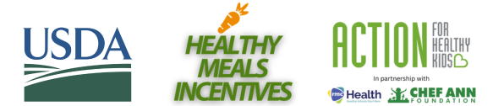
RECOGNITION AWARD TOOLKIT: SOCIAL MEDIA POSTS

Captions for Facebook/LinkedIn:
Great news! We’ve received a Healthy Meals Incentives (HMI) Recognition Award from Action for Healthy Kids, Chef Ann Foundation, and RMC Health for our innovative strategies that provide nutritious school meals. We’re very proud of our staff who have been working hard to earn this recognition! Learn more about the HMI Recognition Awards at https://healthymealsincentives.org/recognition-awards/.

Tag on Facebook: https://www.facebook.com/act4healthykids, https://www.facebook.com/chefannfoundation and https://www.facebook.com/RMCHealth
Tag on LinkedIn: https://www.linkedin.com/company/action-for-healthy-kids/, https://www.linkedin.com/company/chefannfoundation/ and https://www.linkedin.com/company/rmc-health/

Caption for Instagram:
Great news! We’ve received a #HealthyMealsIncentives award from @Act4HealthyKids, @ChefAnnFoundation, and @RMCHealth for our innovative strategies that provide nutritious school meals. So proud of our team! Learn more: https://healthymealsincentives.org/recognition-awards/
Tag on Instagram: @Act4HealthyKids, @ChefAnnFoundation, @RMCHealth
Hashtag: #HealthyMealsIncentives

Caption for X, formerly Twitter:
Great news! We’ve received a #HealthyMealsIncentives award from @Act4HealthyKids, @ChefAnnFnd, and @RMCHealthPD for our innovative strategies that provide nutritious school meals. So proud of our team! Learn more: https://healthymealsincentives.org/recognition-awards/
Tag on X: @Act4HealthyKids, @ChefAnnFnd, and @RMCHealthPD
Hashtag: #HealthyMealsIncentives

