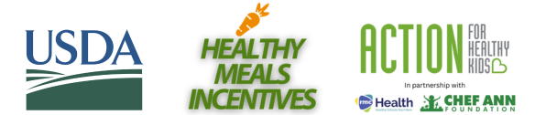
RECOGNITION AWARD TOOLKIT: TALKING POINTS
The following key messages may be helpful to reference when discussing or announcing the award with internal or external audiences (including media).

- We’ve earned the Healthy Meals Incentives [Name of Award] Award from the USDA Food and Nutrition Service and Action for Healthy Kids by making improvements to the nutritional quality of our district’s school meals.

  - [Include two to three sentences summarizing the work that earned your district the recognition award, including any measurable outcomes.]

- The Healthy Meal Incentives Awards spotlight innovative practices, student and community engagement activities, and strategies schools have used to provide meals that are consistent with the 2020-2025 Dietary Guidelines for Americans.

- As part of a cooperative agreement to implement the USDA’s Healthy Meals Incentives Initiative, Action for Healthy Kids is recognizing school districts across the country for improving school nutrition. Learn more and apply at: www.healthymealsincentives.org

  - As an award recipient, we will receive national and local recognition and travel stipends to attend a national Healthy Meals Summit. During the summits, awardees will share best practices and strategies for sustaining their achievements.

- School districts can receive Healthy Meals Incentives Recognition Awards for efforts to improve school nutrition such as lowering sodium and added sugars in school meals; giving healthy makeovers to popular menu items; providing menus that reflect global flavors; and improving nutrition education.

- School meals are great and deserve to be celebrated! Healthy school meals are an essential part of the school environment and access to them improves a child’s health, growth, development, and educational outcomes.

